# Hướng dẫn giải

## First come First serve (FCFS)

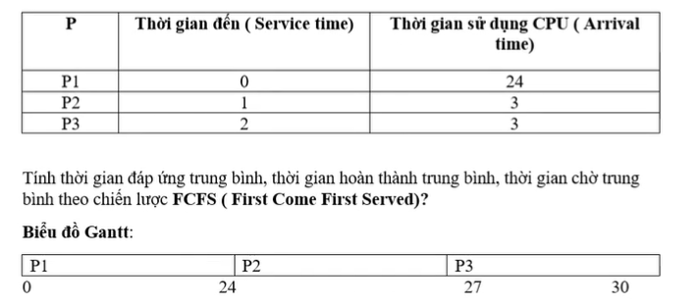

## Shortest Job First (SJF)

## Priority Scheduling

## Round-Robin (RR)

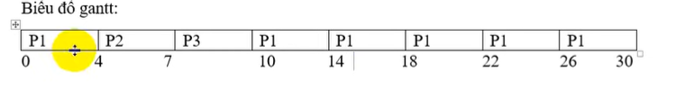

## Highest Respone Ratio Next (HRRN)

